Created Topics :
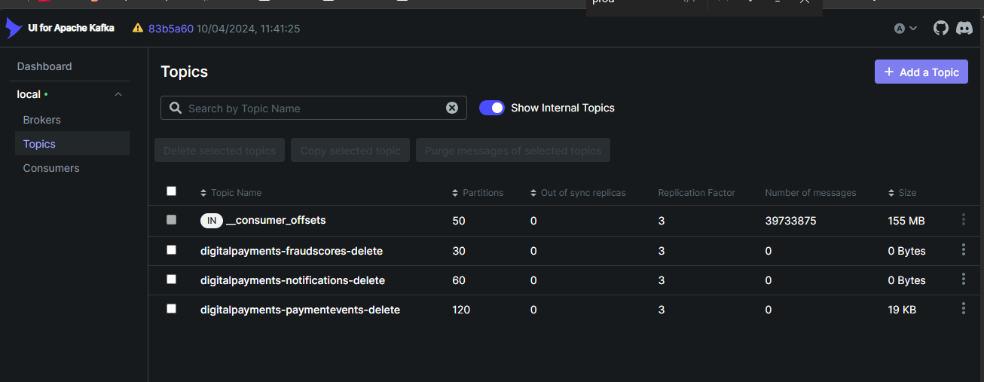

All three topics, along with their respective message counts.
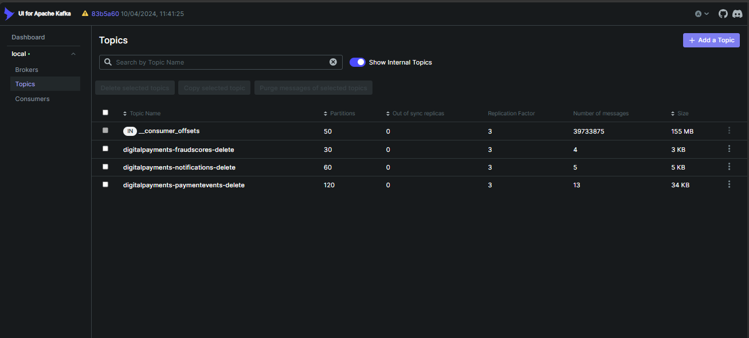

Consumers
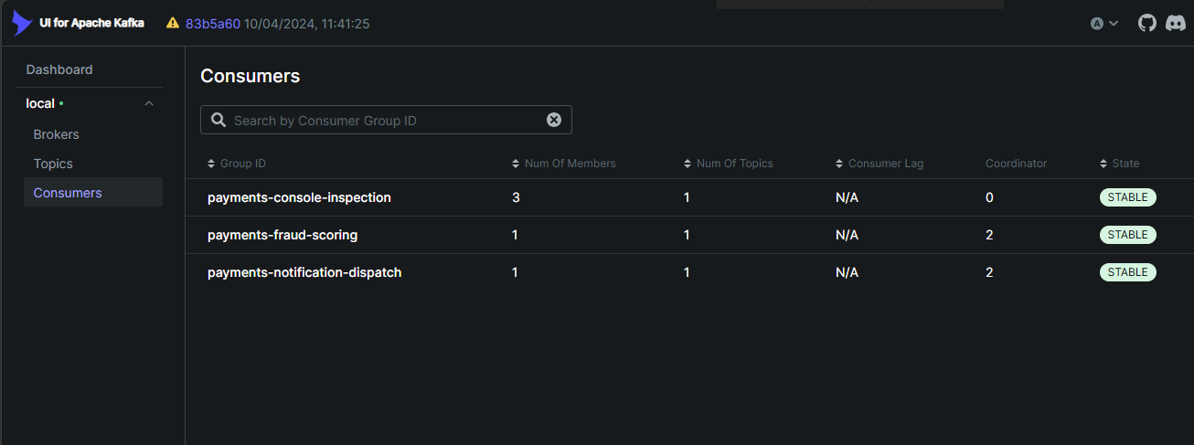

Brokers :
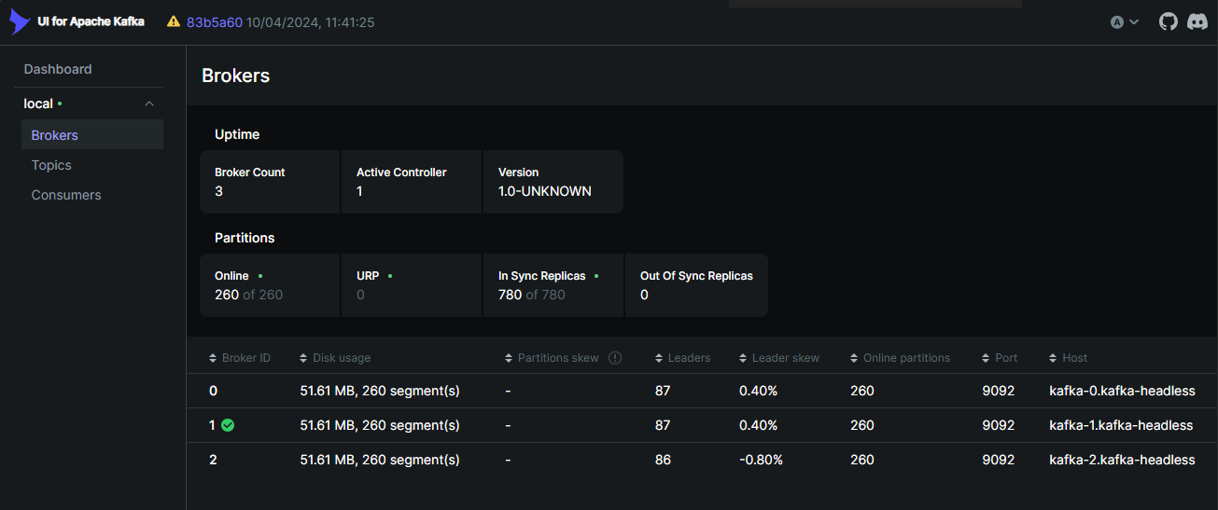

PaymentEvents topic containing messages for payment "PAY-000001".
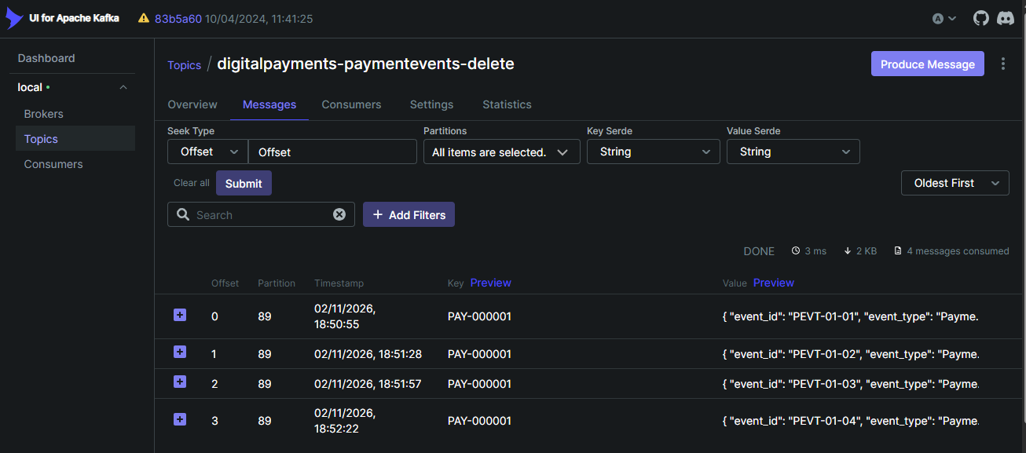

PaymentEvents topic containing all payment messages, with each payment_id assigned its own partition. The offsets for partitions 89, 51, and 67 start at 0, while the offset for partition 110 starts at 2. This is because messages were previously captured and later removed, but they had already consumed offsets within that partition.
.
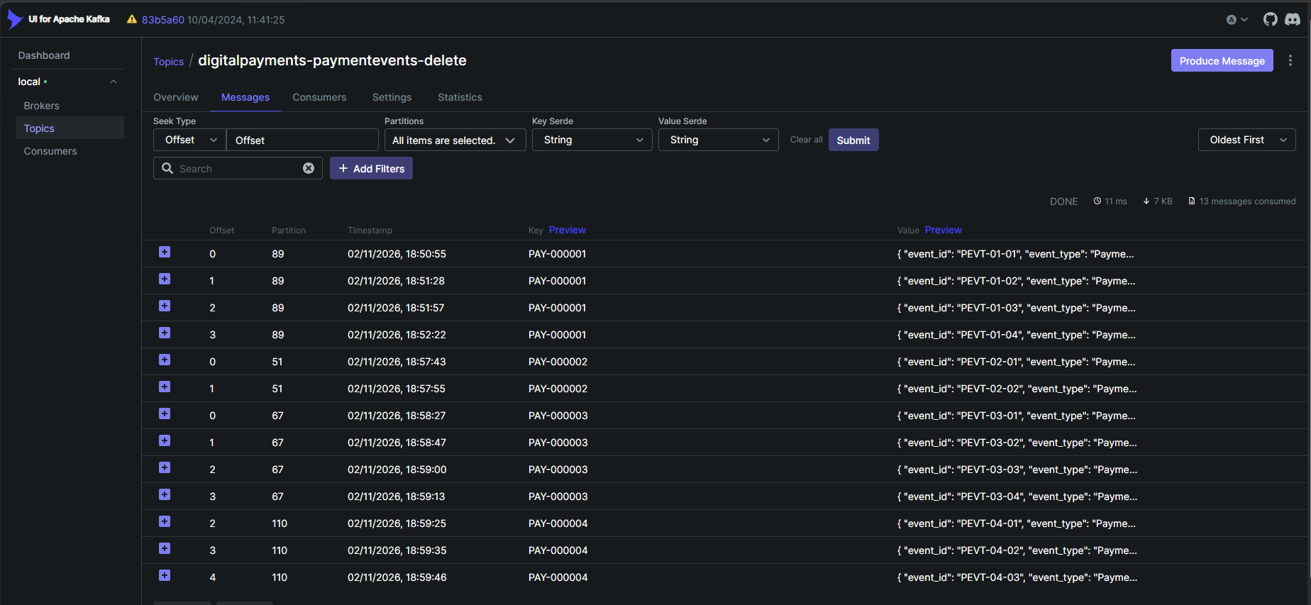
FraudScore topic containing all created messages
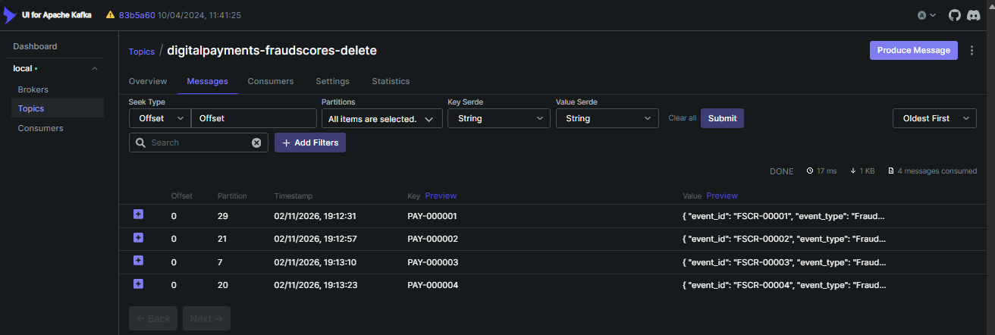

Notifications topic containing all created messages


